Question 22:

After running an ANOVA analysis, we get an F-statistic of 11.9 that translates to a p-value of 6.9746 x 10^(-9), which is extremely low. Hence, we reject the null that the means of all the labs are the same with a 0.05 significance level.

Running Tukey’s method, we get the following 21 confidence intervals for all possible pairs of labs, examining the null hypothesis that the means of the labs in the pair are the same.

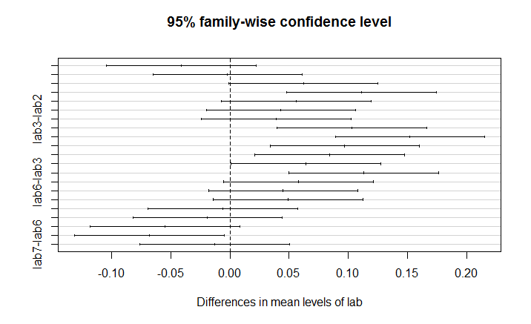

We see that lab7-lab5, lab5- lab3, lab4-lab3, lab7-lab2, lab6-lab2, lab5-lab2, lab4-lab2 and lab5-lab1 have confidence intervals that do not contain 0.

Hence, Lab 5 has a different mean from Lab 7, Lab 3 and Lab 1.  
Lab 4 has a different mean from Lab 3.   
Lab 2 has a different mean from Lab 7, Lab 6, Lab 5 and Lab 4.

This is a similar result to the other manufacturer’s data, where the ANOVA analysis yielded a p-value of less than 0.01. Hence, the null was rejected at 0.05 significance level, and it was found that the mean from lab 1 was significantly different from those from lab 4,5 and 6; the mean of lab 3 was significantly greater than that of lab 4.

R Code:

#Question 22, Chapter 12, Page 509.

tablets2 <- read.csv("tablets2.csv", header=TRUE, sep = ",")

tablets2a <- data.frame(measurement = c(tablets2$Lab1, tablets2$Lab2,

tablets2$Lab3, tablets2$Lab4,

tablets2$Lab5, tablets2$Lab6,

tablets2$Lab7),

lab = rep(paste("lab", 1:7, sep=""), each=10))

i = ncol(tablets2)

j = nrow(tablets2)

df_num = i - 1

df_denom = i*(j-1)

overall_mean = mean(tablets2a$measurement) #Ybar..

treatment_mean = rep(0, i) #Ybari.

for (a in 1:i) {

treatment_mean[a] = mean(tablets2[ , a])

}

ssw = 0

for (a in 1:i) {

ssw = ssw + (j-1)*var(tablets2[ , a])

}

ssb = j*(i-1)*var(treatment_mean)

f_statistic = (ssb/df_num)/(ssw/df_denom)

p_value = pf(f_statistic,df_num, df_denom, lower.tail = FALSE)

#Less than 0.05 so we reject the null with significance level 0.05.

verify <- aov(measurement ~ lab, data = tablets2a) #Gives the same results!

#Now, to use Tukey's method to compare the treatments and see which pairs differ significantly.

#tukey_threshold = qtukey(0.05, i, df_denom, lower.tail = FALSE)*sqrt(ssw/(df_denom*j))

tablets2_tukey = TukeyHSD(verify)

plot(tablets2_tukey)

#We see that lab7-lab5, lab5- lab3, lab4-lab3, lab7-lab2,lab6-lab2, lab5-lab2, lab4-lab2,

#lab5-lab1 have CIs that do not contain 0.

Question 28:

After running an ANOVA analysis, we get an F-statistic of 0.497 that translates to a p-value of 0.617, which is extremely high. Hence, we fail to reject the null that the means of all the types of watches are the same with a 0.05 significance level.

R Code:

#Question 28, Chapter 12, Page 510.

watches <- read.csv("watches.csv", header=TRUE, sep = ",")

watchesa <- data.frame(measurement = c(watches$Type.1, watches$Type.2,

watches$Type.3),

type = rep(paste("type", 1:3, sep=""), each=9))

watchesa <- watchesa[-c(16, 17, 18, 24, 25, 26, 27), ]

i = ncol(watches)

j = c(9, 6, 5)

df_num = i - 1

df_denom = sum(j-1)

overall_mean = mean(watchesa$measurement) #Ybar..

treament_mean = c(mean(watches[ , 1]), mean(watches[ , 2][- c(7,8,9)]),

mean(watches[ , 3][- c(6, 7,8,9)]))

ssw = 8*var(watches[ , 1]) + 5*var(watches[ , 2][- c(7,8,9)]) + 4*var(watches[ , 3][- c(6, 7,8,9)])

ssb = 9*(treament_mean[1] - overall_mean)^2 + 6*(treament_mean[2] - overall_mean)^2 + 5*(treament_mean[3] - overall_mean)^2

f_statistic = (ssb/df_num)/(ssw/df_denom)

p_value = pf(f_statistic,df_num, df_denom, lower.tail = FALSE)

#Greater than 0.05 so we fail to reject the null with significance level 0.05.

verify <- aov(measurement ~ type, data = watchesa) #Gives the same results!